ACH / BANK DRAFT AUTHORIZATION

AUTHORIZATION AGREEMENT FOR ACH COLLECTIONS

INDIVIDUAL NAME: _________________________________________________________________________
SERVICE ADDRESS: _________________________________________________________________________
ACCOUNT NUMBER: _________________________________________________________________________

I hereby authorize Putnam Community Water to initiate debit entries and to initiate, if necessary, credit entries and adjustments for any debit entries in error to my account or accounts listed below.

ABOUT YOUR ACCOUNT(S)

(Where your water payment is to be drawn from)

FINANCIAL INSTITUTION NAME:

FINANCIAL INSTITUTION ACCOUNT #
ROUTING #

TYPE OF ACCOUNT CHECKING SAVINGS

This authority is to remain in full force until Putnam Community Water has received written notification from me of its termination in such timely manner as to afford Putnam Community Water and FINANCIAL INSTITUTION a reasonable opportunity to act on it.

NAME:

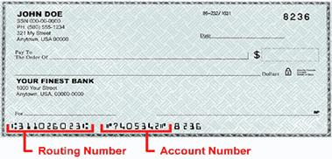
DATE: SIGNATURE:
VOID
Attach Voided Check Here

